Neurology, Neurons, and EEG

Neurology is a study of the nervous system. The nervous system is categorized into two physical parts: the peripheral nervous system and the central nervous system. The peripheral nervous system is most easily described by what it is not…it is everything BUT the spinal cord and brain. The central nervous system [CNS] is made of the spinal cord and the brain (including the brain stem). The CNS is composed of two main kinds of cells: neurons and glia.

Glia, neuroglia or glial cells have the following 4 main functions:

to surround neurons and hold them in place;
to supply nutrients and oxygen to neurons;
to insulate one neuron from another;
to destroy pathogens and remove dead neurons.

There are many more glial cells than neurons. We do not fully understand the function of glial cells.

Neurons are the basic “information processing” cells of the CNS. The information they process is carried in the form of electrical and chemical messages. The Neurons carry these messages and somehow process and store information ultimately producing the existence of our minds. Neurons are also found in the peripheral nervous system, but we will ignore these in this paper since we are addressing the neurons of the brain so as to be able to get a grasp of what an EEG is measuring.

Neurons receive "information" from other neurons (input), they also send "information" to other neurons (output). All this is done in a combination of electrical and chemical messages. A neuron moves “information” within itself in an electrical message called an action potential. The message moves down a long fiber of the neuron called an axon. An axon of one neuron connects to small projections (dendrites) of another neuron over a loose connection called a synapse. Synapses are connections among neurons. The "information" that flows from one neuron to another over synapses is not by an electrical message but by a chemical transmitter…a neurotransmitter. Here are some images that help explain this system.

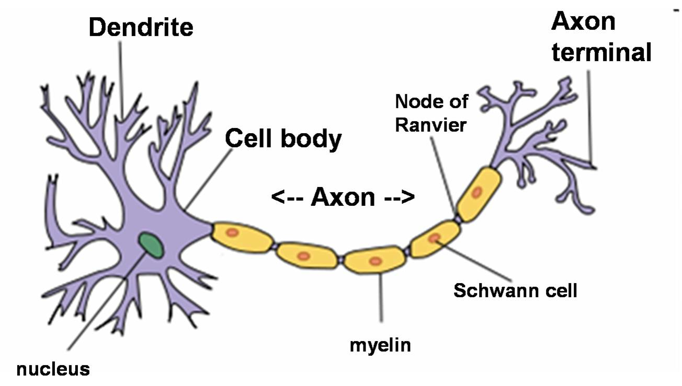
Dendrites are small projections of the neuron that receive information. The axon is the conductor of the neuron that carries electrical information away from the cell body towards the terminus and can cause the release of chemical neurotransmitters across the synapses…see next figure.

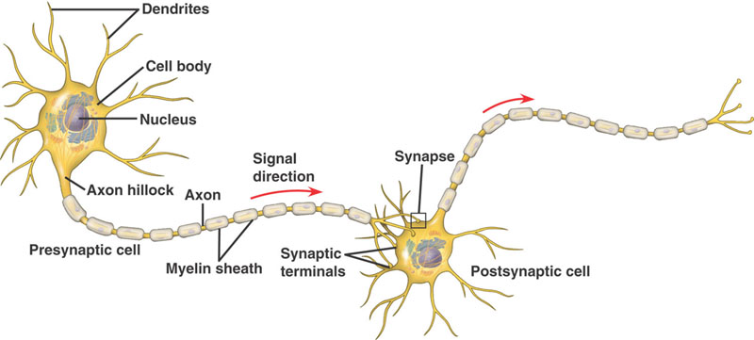

Information is carried from neuron to neuron by BOTH electrical and chemical messages. The electrical message is typically received at one end and moved away from the cell body down the axon to the synapses.

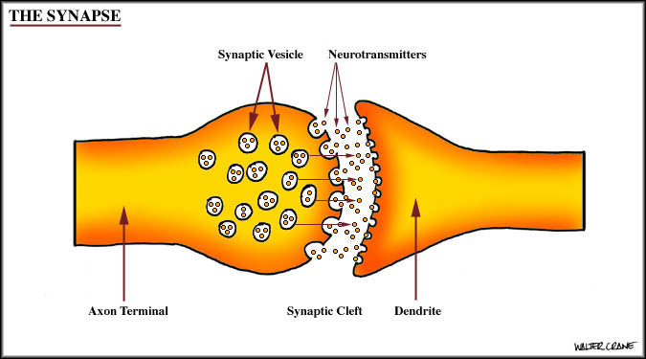
A synapse is shown on the left. An electrical message moves down the axon causing the release of a neurotransmitter into the synaptic space (cleft). The neurotransmitter will stimulate the dendrite and in some case cause the next neuron to carry the message (information) further.

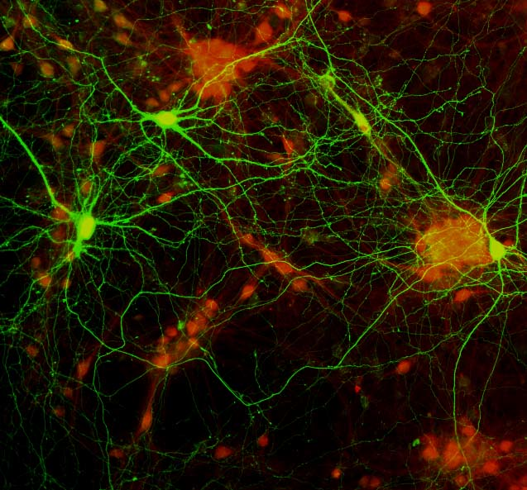

The real thing is far more complex, as in this fluorescent-labeled image of neurons showing a network of cells.

There are many billions of neurons in the brain and there are many ways they interact and communicate. The basic concept to remember is that neurons work together by a combination of electrical and chemical messages.

To understand the how neurons transmit electrical messages (information) we should review a few basics of electricity.

Charge is either positive or negative. Charges only come in whole numbers. Charges can be either positive or negative. Like charges repel and opposite charges attract…that is where the saying, “opposites attract” and the notion of persons with opposite personalities are attracted to each other arises. Whether this is true or not is an age-old question.

Voltage or electrical potential is measured in volts. A voltage arises when charges are separated, but are close enough to have an attraction or repulsion.

Charges obey the INVERSE SQUARE LAW…charge attraction or repulsion falls off with the square of the distance.

Protons confer positive charge and electrons confer a negative charge. The single positive charge of a proton will balance the single negative charge of an electron resulting NO net charge. Atoms have protons in their nuclei and atoms at temperatures outside of stars often have electrons “orbiting” in clouds around the nuclei. If the electron number of an atom equals the number of protons, the net charge of the atom is ZERO and the atom is neutral…if the balance of protons and electrons is not equal, the atom is an ion.

Membrane Potential (how all this leads up to how a neuron functions)

All organisms have various ions inside and outside of their cells. The separation of ions or charges is the reason there is a voltage associated with living cells. The membrane of a cell is what separates the charges leading to a voltage. Biologists call this a membrane voltage potential or simply…membrane potential.

All living cells have some separation of ions (charges) on either side of their membranes. This creates a membrane potential…voltage. Most living cells have a membrane potential that is kept constant…somewhere around -40 millivolts to -80 millivolts. Biologists refer to the more negative on one side and more positive on the other as “polarized”. We say negatively polarized because the inside of the cell is more negative than the outside.

Some of the most important intracellular (inside the cell) and extracellular (outside of the cell) ions are sodium (Na+) potassium (K+) and chloride (Cl−) ions. This is not surprising since these are common ions in sea water…where life was first common.

Animal cells have an important system of pumps in their membranes that keep the ion concentrations on either side of the membrane relatively stable. It is called the sodium potassium pump. This system pumps out more sodium (Na+) from inside the cell out of the cell and more potassium (K+) from outside the cell into the cell resulting in the cell having an imbalance of more sodium outside the cell and more potassium inside the cell.

Other cellular ions have different concentrations inside and outside the neuron, such as calcium (Ca++), and magnesium (Mg++).

An interesting note…up to 50% of a normal cells energy in a human body is required to run the sodium potassium pump!

How does the sodium potassium pump work?

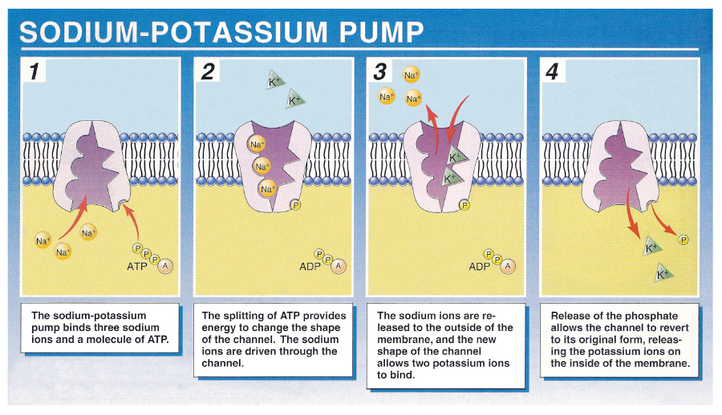

THE NEURON…you thought we would never get here!

Neurons have a peculiar design that allows them to change their membrane potential by suddenly becoming leaky and allowing an inrush of Na+ from outside the cell where there is a greater concentration of Na+. This causes the charge inside the neuron to go from -60 millivolts (mv) to +40 mv. Neurons are also designed to allow this change in polarity (negative inside the cell positive inside the cell) to occur in a wave moving down the long end of the neuron (the axon). When the electrical reversal reaches the end of the axon and causes the release of a neurotransmitter across the synapse to the next neuron. There are many ways that neurons can regulate the message across the synapse. This allows a controlled movement of electrical message from neuron to neuron. The numerous drugs that are used in medicine to treat people are often effective at the synapse.
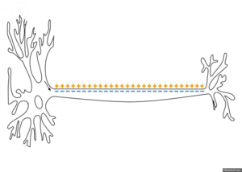

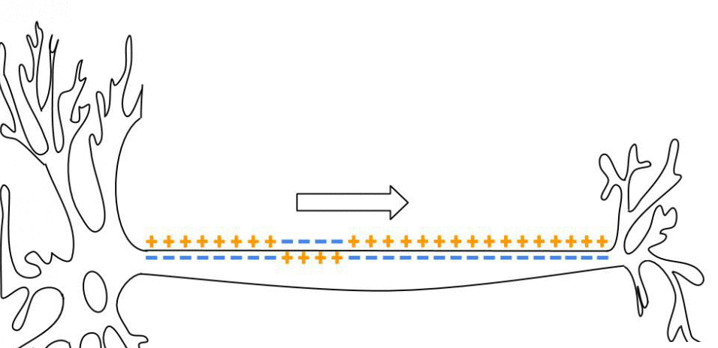

As an action potential travels down the axon, there is a change in polarity across the membrane. The Na⁺ and K⁺ gated ion channels open and close as the membrane reaches the threshold potential, in response to a signal from another neuron. At the beginning of the action potential, the Na⁺ channels open and Na⁺ moves into the axon, causing depolarization. Repolarization occurs when the K⁺ channels open and K⁺ moves out of the axon. This creates a change in polarity between the outside of the cell and the inside. The impulse travels down the axon in one direction only, to the axon terminal where it signals other neurons. (source WIKI)

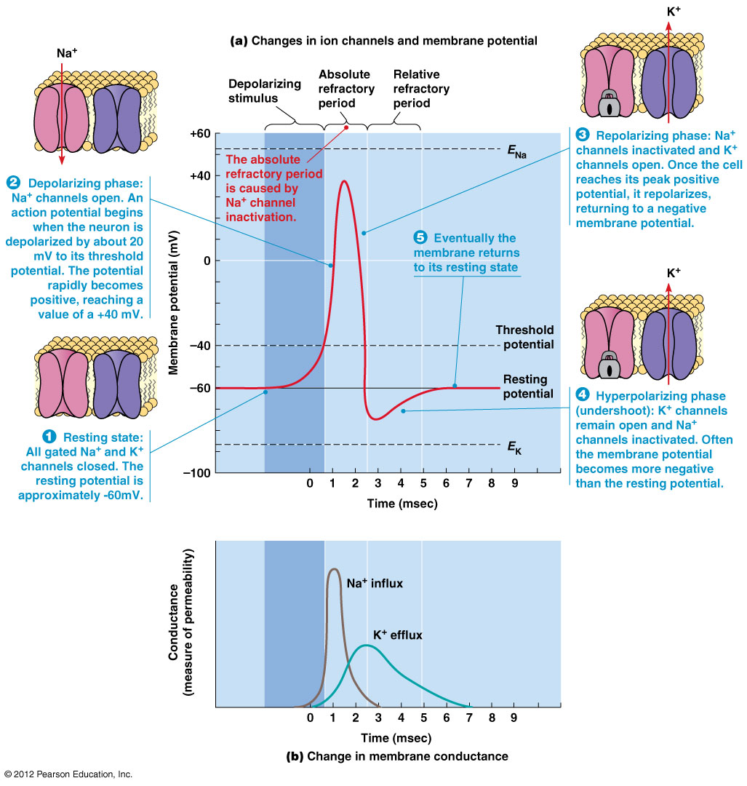
A review of the entire sequence of the action potential

Wrapping Up



There are billions of neurons in the brain and their constant firing produces electrical potential that reach the skin. An EEG is a device that is indirectly measuring the electrical potentials involved with millions of neurons.

The more detailed explanation of neurons is at the following link. Scroll down to the animations to watch how conduction of messages occurs. Make sure to watch the 8 steps of the action potential and take notes of each step.

http://www.mind.ilstu.edu/curriculum/neurons_intro/neurons_intro.php

