Enlightenment Reader
Crossroads Academy



“Reading furnishes the mind only with materials of knowledge; it is thinking that makes what we read ours.”
-–John Locke

“In order to improve the mind, we ought less to learn, than to contemplate.” --Rene Descartes

“Have the courage to use your own reason- That is the motto of enlightenment.” -–Immanuel Kant

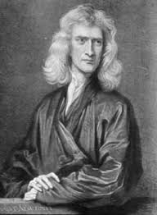

Isaac Newton

Every body continues in its state of rest, or of uniform motion in a right line, unless it is compelled to change that state by forces impressed upon it.
The relationship between an object's mass m, its acceleration a, and the applied force F is F = ma.
For every action there is an equal and opposite re-action.
Plato is my friend—Aristotle is my Friend—but my greatest friend is truth.
If I have seen further than others, it is by standing upon the shoulders of giants.

A man may imagine things that are false, but he can only understand things that are true, for if the things be false, the apprehension of them is not understanding.
I do not know what I may appear to the world, but to myself I seem to have been only like a boy playing on the sea-shore, and diverting myself in now and then finding a smoother pebble or a prettier shell than ordinary, whilst the great ocean of truth lay all undiscovered before me.
To me there has never been a higher source of earthly honor or distinction than that connected with advances in science.
It is the weight, not numbers of experiments that is to be regarded.
(Newton, Continued )
We are to admit no more causes of natural things than such as are both true and sufficient to explain their appearances.
Truth is ever to be found in the simplicity, and not in the multiplicity and confusion of things.
If I have ever made any valuable discoveries, it has been due more to patient attention, than to any other talent.
Men build too many walls and not enough bridges.
Tact is the art of making a point without making an enemy.

I can calculate the motion of heavenly bodies, but not the madness of people.

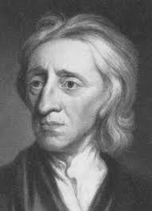
John Locke

No man's knowledge here can go beyond his experience.

Every man has a property in his own person. This nobody has a right to, but himself.
All wealth is the product of labor.

All mankind... being all equal and independent, no one ought to harm another in his life, health, liberty or possessions.

(Locke, Continued)
Government has no other end, but the preservation of property.

The end of law is not to abolish or restrain, but to preserve and enlarge freedom.
Revolt is the right of the people
There is frequently more to be learned from the unexpected questions of a child than the discourses of men.

It is one thing to show a man that he is in an error, and another to put him in possession of the truth.
The dread of evil is a much more forcible principle of human actions than the prospect of good.

We are like chameleons; we take our hue and the color of our moral character, from those who are around us.
I have always thought the actions of men the best interpreters of their thoughts.
Our incomes are like our shoes; if too small, they gall and pinch us; but if too large, they cause us to stumble and to trip.

Reading furnishes the mind only with materials of knowledge; it is thinking that makes what we read ours.

New opinions are always suspected, and usually opposed, without any other reason but because they are not common.
The only defense against the world is a thorough knowledge of it.
To love truth for truth's sake is the principal part of human perfection in this world, and the seed-plot of all other virtues.

Parents wonder why the streams are bitter, when they themselves poison the fountain.

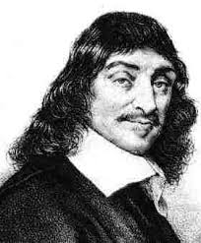
Descartes

It is not enough to have a good mind; the main thing is to use it well.

Divide each difficulty into as many parts as is feasible and necessary to resolve it.
The senses deceive from time to time, and it is prudent never to trust wholly those who have deceived us even once.

If you would be a real seeker after truth, it is necessary that at least once in your life you doubt, as far as possible, all things.

The first precept was never to accept a thing as true until I knew it as such without a single doubt.

I am accustomed to sleep and in my dreams to imagine the same things that lunatics imagine when awake.

I suppose therefore that all things I see are illusions; I believe that nothing has ever existed of everything my lying memory tells me. I think I have no senses. I believe that body, shape, extension, motion, location are fictions. What is there then that can be taken as true? Perhaps only this one thing, that nothing at all is certain.

Doubt is the origin of wisdom

I think; therefore I am.

(Descartes, Continued)
The reading of all good books is like a conversation with the finest minds of past centuries.

Except our own thoughts, there is nothing absolutely in our power.

In order to improve the mind, we ought less to learn, than to contemplate.

I am indeed amazed when I consider how weak my mind is and how prone to error.

There is nothing so strange and so unbelievable that it has not been said by one philosopher or another.

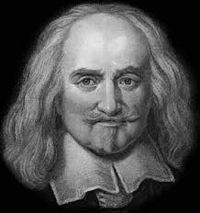
Thomas Hobbes

There is no such thing as perpetual tranquility of mind while we live here; because life itself is but motion, and can never be without desire, nor without fear, no more than without sense.

I put for the general inclination of all mankind, a perpetual and restless desire of power after power, that ceaseth only in death.

The condition of man . . . is a condition of war of everyone against everyone.
Force and fraud are in war the two cardinal virtues.

(Hobbes, Continued)
Whatsoever therefore is consequent to a time of war, where every man is enemy to every man, the same consequent to the time wherein men live without other security than what their own strength and their own invention shall furnish them withal. In such condition there is no place for industry... no knowledge of the face of the earth; no account of time; no arts; no letters; no society; and which is worst of all, continual fear, and danger of violent death; and the life of man, solitary, poor, nasty, brutish, and short.

The right of nature... is the liberty each man hath to use his own power, as he will himself, for the preservation of his own nature; that is to say, of his own life.

That a man be willing, when others are so too, as far forth as for peace and defense of himself he shall think it necessary, to lay down this right to all things; and be contented with so much liberty against other men, as he would allow other men against himself.
A man cannot lay down the right of resisting them that assault him by force, to take away his life.
During the time men live without a common power to keep them all in awe, they are in that conditions called war; and such a war, as if of every man, against every man.
Force and fraud are in war the two cardinal virtues.
The obligation of subjects to the sovereign is understood to last as long, and no longer, than the power lasteth by which he is able to protect them.
Such is the nature of men, that howsoever they may acknowledge many others to be more witty, or more eloquent, or more learned; yet they will hardly believe there be many so wise as themselves: For they see their own wit at hand, and other men’s at a distance.

If I read as many books as most men do, I would be as dull-witted as they are.

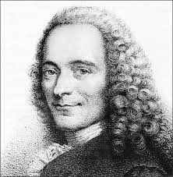
Voltaire

I have never made but one prayer to God, a very short one: 'O Lord make my enemies ridiculous.' And God granted it.

God is a comedian, playing to an audience too afraid to laugh.

I do not agree with what you have to say, but I'll defend to the death your right to say it.

It is difficult to free fools from the chains they revere.
Stand upright, speak thy thoughts, declare the truth thou hast, that all may share; be bold, proclaim it everywhere: They only live who dare.
What is tolerance? It is the consequence of humanity. We are all formed of frailty and error; let us pardon reciprocally each other's folly - that is the first law of nature.
It is dangerous to be right in matters on which the established authorities are wrong.

Anyone who has the power to make you believe absurdities has the power to make you commit injustices.
God gave us the gift of life; it is up to us to give ourselves the gift of living well.

(Voltaire, Continued)
Appreciation is a wonderful thing: It makes what is excellent in others belong to us as well.

Common sense is not so common.

In general, the art of government consists of taking as much money as possible from one class of citizens to give to another.

Every man is guilty of all the good he did not do.
It is forbidden to kill; therefore all murderers are punished unless they kill in large numbers and to the sound of trumpets.
Judge a man by his questions rather than his answers.
Let us read and let us dance - two amusements that will never do any harm to the world.

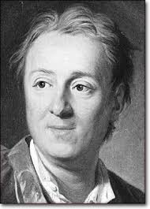
Denise Diderot

Only passions, great passions, can elevate the soul to great things.

We swallow greedily any lie that flatters us, but we sip only little by little at a truth we find bitter.

(Diderot, Continued)
It is very important not to mistake hemlock for parsley, but to believe or not believe in God is not important at all.

Man will never be free until the last king is strangled with the entrails of the last priest.

The philosopher has never killed any priests, whereas the priest has killed a great many philosophers.

Disturbances in society are never more fearful than when those who are stirring up the trouble can use the pretext of religion to mask their true designs.
There are things I can't force. I must adjust. There are times when the greatest change needed is a change of my viewpoint.
There are three principal means of acquiring knowledge... observation of nature, reflection, and experimentation. Observation collects facts; reflection combines them; experimentation verifies the result of that combination.

From fanaticism to barbarism is only one step.
No man has received from nature the right to command his fellow human beings.
The infant runs toward it with its eyes closed, the adult is stationary, the old man approaches it with his back turned.

Watch out for the fellow who talks about putting things in order! Putting things in order always means getting other people under your control.
Good music is very close to primitive language.
It is not human nature we should accuse but the despicable conventions that pervert it.
Skepticism is the first step on the road to philosophy.

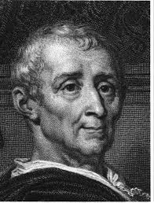
Montesquieu

To become truly great, one has to stand with people, not above them.
The tyranny of a prince in an oligarchy is not so dangerous to the public welfare as the apathy of a citizen in a democracy.
It is not the young people that degenerate; they are not spoiled till those of mature age are already sunk into corruption.

If we only wanted to be happy, it would be easy; but we want to be happier than other people, and that is almost always difficult, since we think them happier than they are.
In the infancy of societies, the chiefs of state shape its institutions; later the institutions shape the chiefs of state.
Luxury ruins republics; poverty, monarchies.
No kingdom has shed more blood than the kingdom of Christ.
Useless laws weaken the necessary laws.
Countries are well cultivated, not as they are fertile, but as they are free.
If the triangles made a god, they would give him three sides.
The reason the Romans built their great paved highways was because they had such inconvenient footwear.
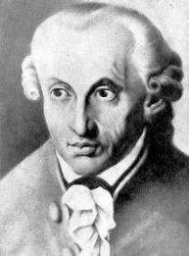
Immanuel Kant

Enlightenment is man’s leaving his self-caused immaturity. Immaturity is the incapacity to use one's intelligence without the guidance of another. Such immaturity is self-caused if it is not caused by lack of intelligence, but by lack of determination and courage to use one's intelligence without being guided by another. Sapere Aude! Have the courage to use your own intelligence! is therefore the motto of the enlightenment...

Laziness and cowardice explain why so many men. . . remain under a life-long tutelage and why it is so easy for some men to set themselves up as the guardians of all the rest. . . If I have a book which understands for me, a pastor who has a conscience for me, a doctor who decides my diet, I need not trouble myself. If I am willing to pay, I need not think. Others will do it for me.
Science is organized knowledge. Wisdom is organized life.

Always treat people as ends in themselves, never as means to an end.

Look closely. The beautiful may be small.

One who makes himself a worm cannot complain afterwards if people step on him.

Two things inspire me to awe: the starry heavens above and the moral universe within.

(Immanuel Kant, Continued)
All our knowledge begins with the senses, proceeds then to the understanding, and ends with reason. There is nothing higher than reason.

He who is cruel to animals becomes hard also in his dealings with men. We can judge the heart of a man by his treatment of animals.

We are not rich by what we possess but by what we can do without.

Seek not the favor of the multitude... But seek the testimony of the few; and number not the voices, but weigh them.

To Be is To Do.

Have patience awhile; slanders are not long-lived. Truth is the child of time; erelong she shall appear to vindicate thee.

Have the courage to use your own reason- That is the motto of enlightenment.
How then is perfection to be sought? Wherein lies our hope? In education, and in nothing else.

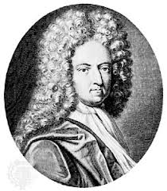
Daniel Defoe

The soul is placed in the body like a rough diamond, and must be polished, or the luster of it will never appear.
'Tis no sin to cheat the devil.

It is never too late to be wise.

Expect nothing and you'll always be surprised.

Thus we never see the true state of our condition till it is illustrated to us by its contraries, nor know how to value what we enjoy, but by the want of it.

He that hath truth on his side is a fool as well as a coward if he is afraid to own it because of other men’s opinions.

Thus fear of danger is ten thousand times more terrifying than danger itself when apparent to the eyes; and we find the burden of anxiety greater, by much, than the evil which we are anxious about.

All our discontents about what we want appeared to me to spring from the want of thankfulness for what we have.

I have often thought of it as one of the most barbarous customs in the world, considering us as a civilized and a Christian country, that we deny the advantages of learning to women.

Nature has left this tincture in the blood, that all men would be tyrants if they could/

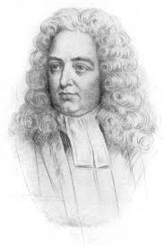
Jonathan Swift

Principally I hate and detest that animal called man; although I heartily love John, Peter, Thomas, and so forth.

When a true genius appears, you can know him by this sign: that all the dunces are in a confederacy against him.

Vision is the art of seeing what is invisible to others.

…all government without the consent of the governed is the very definition of slavery.

We have enough religion to make us hate, but not enough to make us love one another.

Satire is a sort of glass, wherein beholders do generally discover everybody's face but their own.

Nothing is so hard for those who abound in riches as to conceive how others can be in want.

Good manners is the art of making those people easy with whom we converse. Whoever makes the fewest people uneasy is the best bred in the room.

(Jonathan Swift, Continued)
A man should never be ashamed to own that he has been in the wrong, which is but saying... that he is wiser today than yesterday.

Every man desires to live long, but no man wishes to be old.

There are few, very few, that will own themselves in a mistake.

No wise man ever wished to be younger.

Power is no blessing in itself, except when it is used to protect the innocent.

Invention is the talent of youth, and judgment of age.

The latter part of a wise person's life is occupied with curing the follies, prejudices and false opinions they contracted earlier.
The proper words in the proper places are the true definition of style.

Most sorts of diversion in men, children and other animals, are in imitation of fighting.

It is a maxim among these lawyers, that whatever hath been done before, may legally be done again: and therefore they take special care to record all the decisions formerly made against common justice and the general reason of mankind.

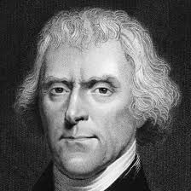
Thomas Jefferson
When the people fear the government, there is tyranny. When the government fears the people, there is liberty.

I never considered a difference of opinion in politics, in religion, in philosophy, as cause for withdrawing from a friend.

The tree of liberty must be refreshed from time to time with the blood of tyrants.

The glow of one warm thought is to me worth more than money.
Do you want to know who you are? Don't ask. Act! Action will delineate and define you.

Nothing can stop the man with the right mental attitude from achieving his goal; nothing on earth can help the man with the wrong mental attitude.
I believe that banking institutions are more dangerous to our liberties than standing armies.
I tremble for my country when I reflect that God is just; that his justice cannot sleep forever.

I hope we shall crush in its birth the aristocracy of our monied corporations which dare already to challenge our government to a trial by strength, and bid defiance to the laws of our country.

(Thomas Jefferson, Continued)
Experience has shown that, even under the best forms of government, those entrusted with power have, in time, and by slow operations, perverted it into tyranny.

A Bill of Rights is what the people are entitled to against every government, and what no just government should refuse, or rest on inference.

Our greatest happiness does not depend on the condition of life in which chance has placed us, but is always the result of a good conscience, good health, occupation, and freedom in all just pursuits.
When we get piled upon one another in large cities, as in Europe, we shall become as corrupt as Europe.

To compel a man to furnish funds for the propagation of ideas he disbelieves and abhors is sinful and tyrannical.

Educate and inform the whole mass of the people... They are the only sure reliance for the preservation of our liberty.

